Small Language Model

# What is SLM?

* < 1 billion – Small Language model
* Target here – 15m

# Course

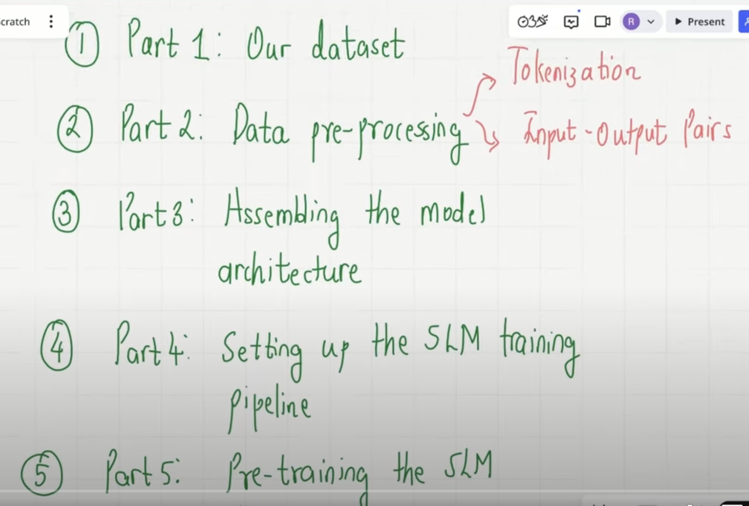

# Part 1 – Our Dataset

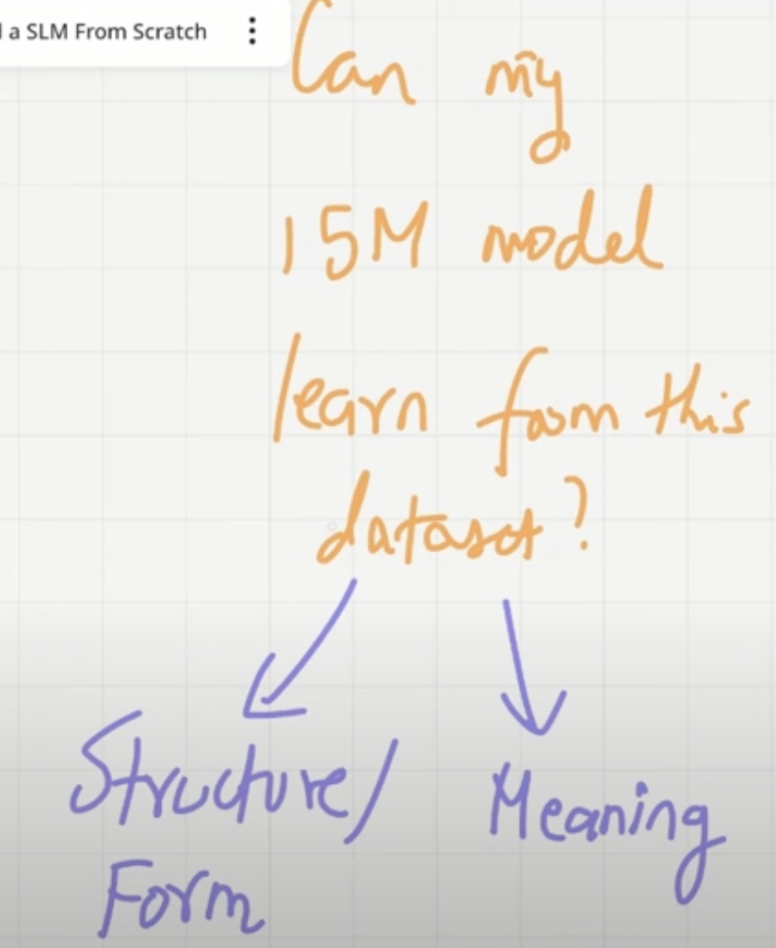

* Tiny Stories for data (stories for 3-4 year old, 2 million in training). Will help to reduce size of model

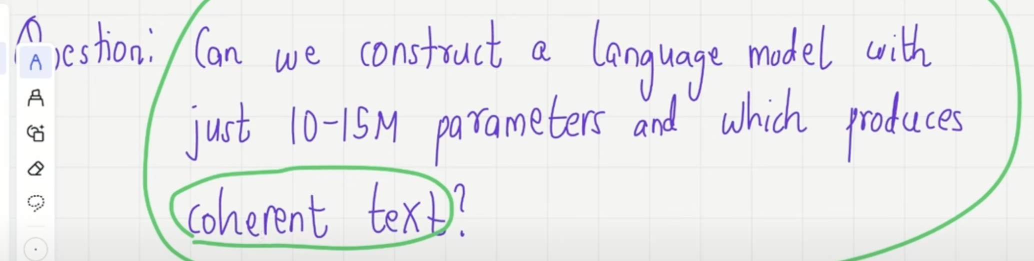

* How the model without knowing language get the information of language from just those stories. This makes the problem more interesting.

# Part 2 – Data Preprocessing

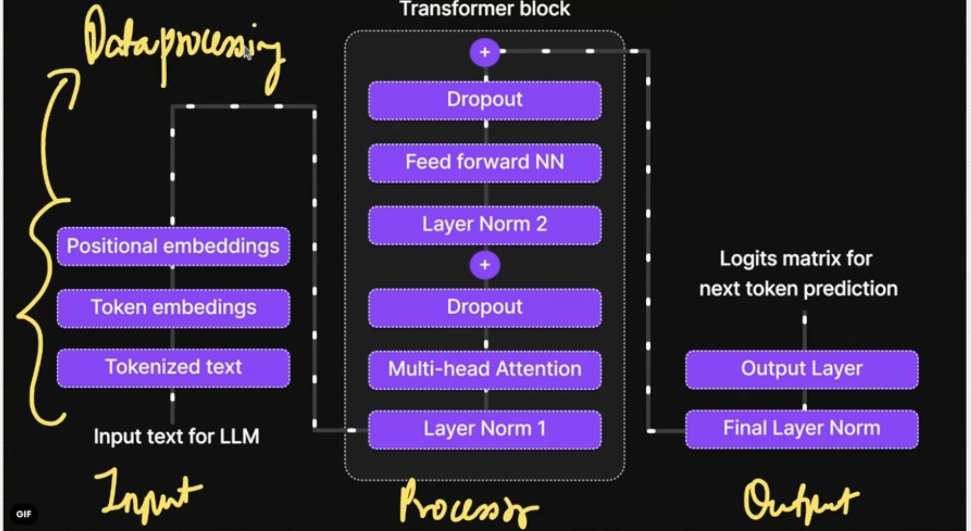

* Input block for Data Pre-processing
* Sub Word Tokenization – Byte Pair algorithm (BPE)
  + Dataset -> Tokenizer -> Tokens -> Token IDs
* Tokenizer same as GPT2 Sub-word tokenizer,
* Inspired from Nano-GPT logic(Andrew GPT)
* **Goal**

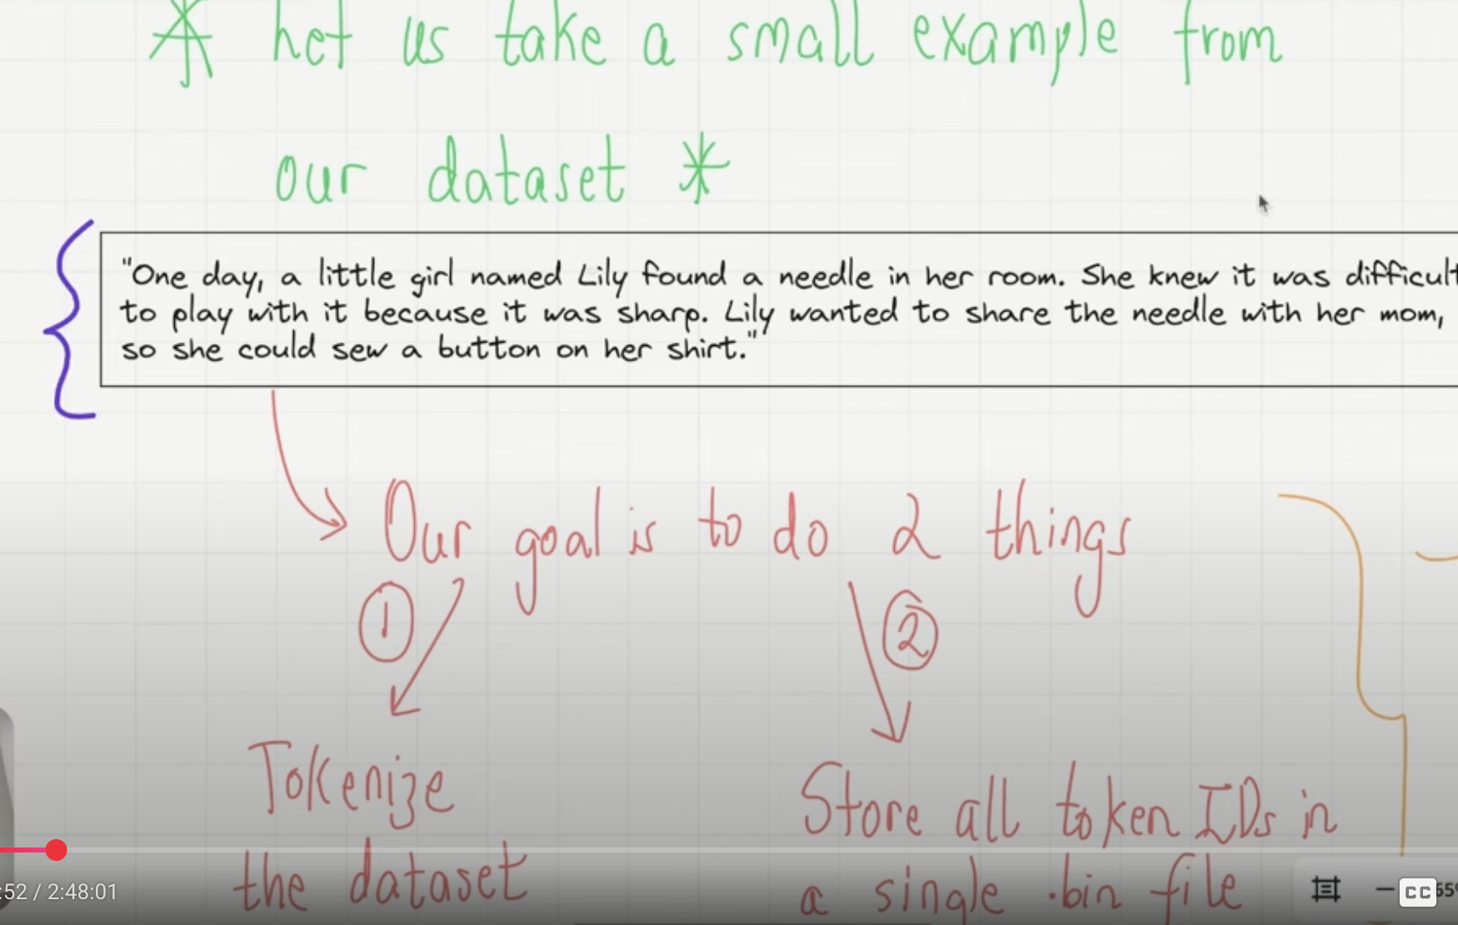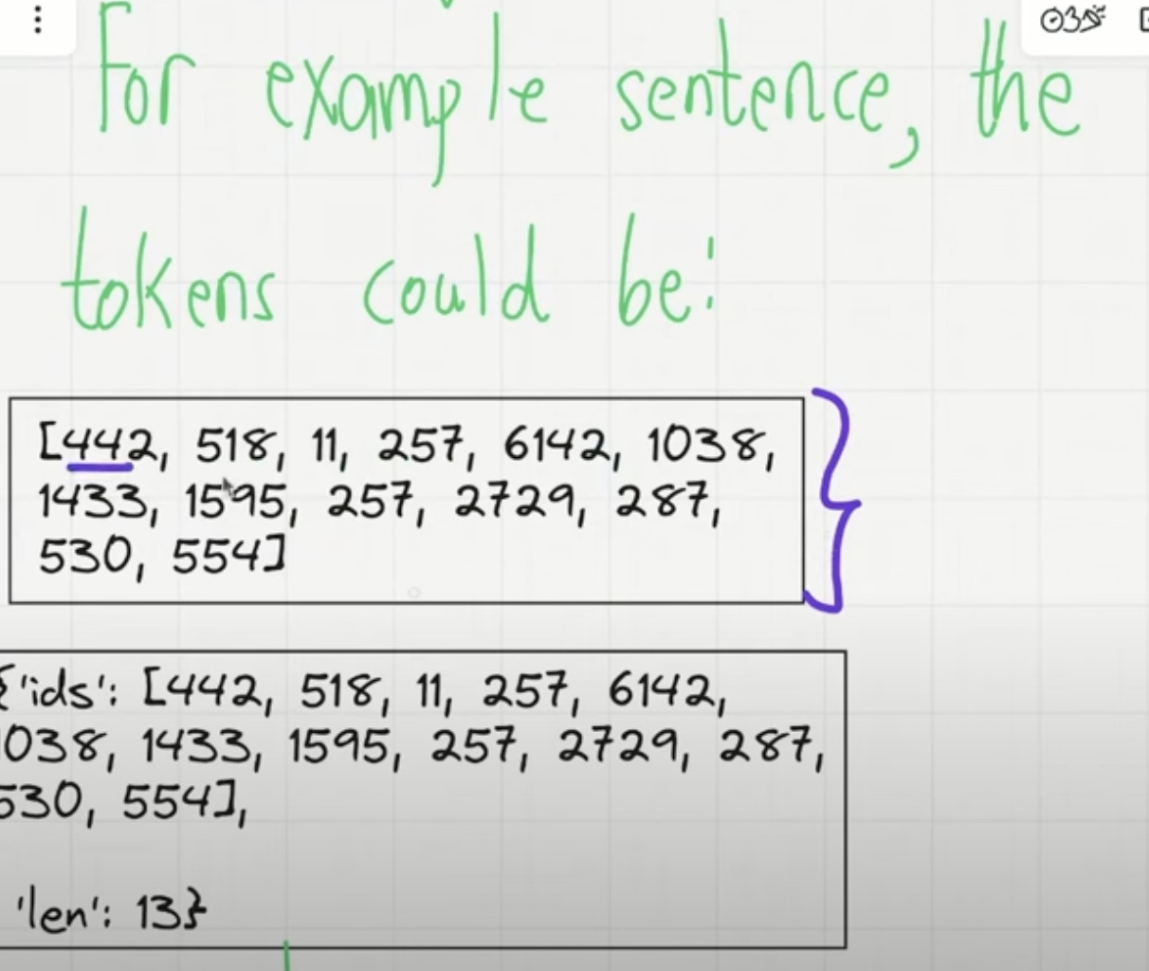

* Why store in disk ?
  + train.bin (memory mapped array)

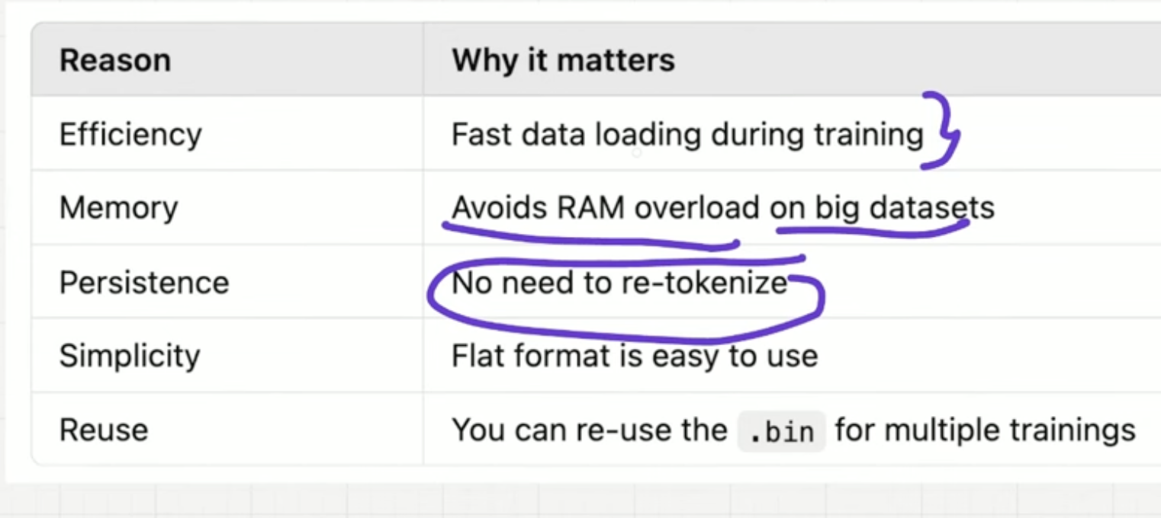

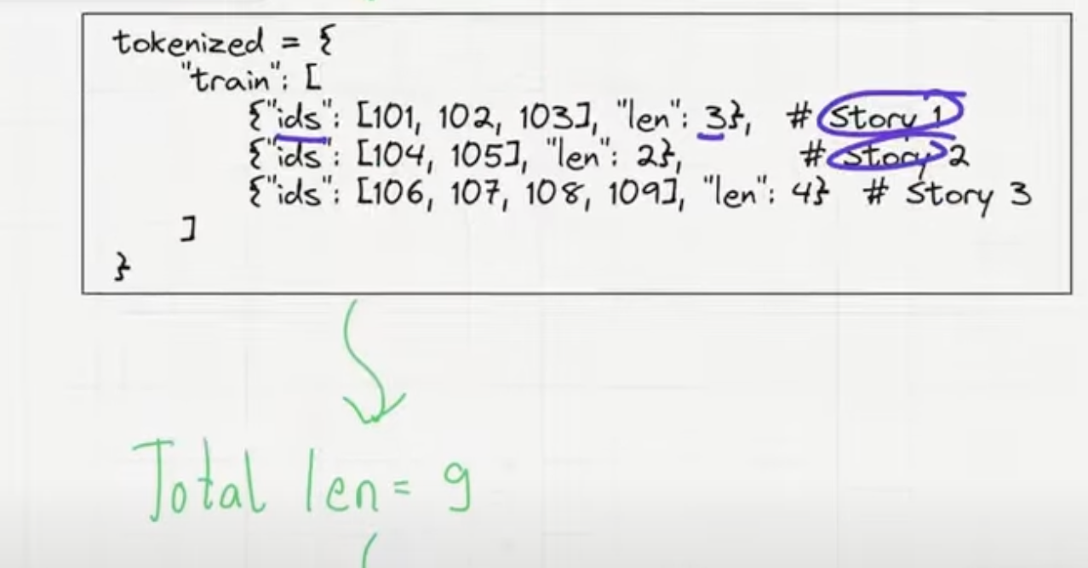

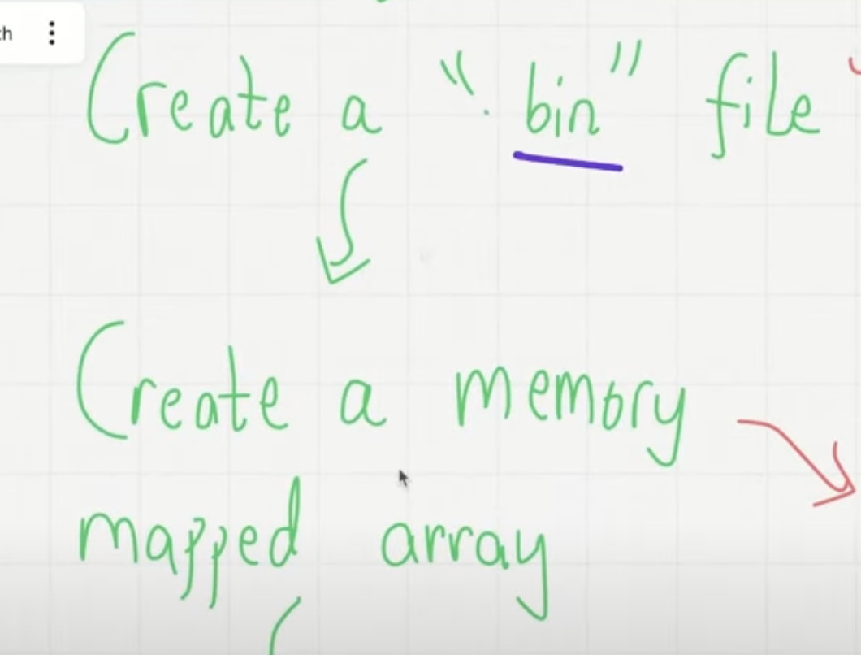 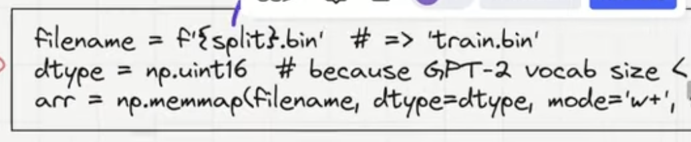

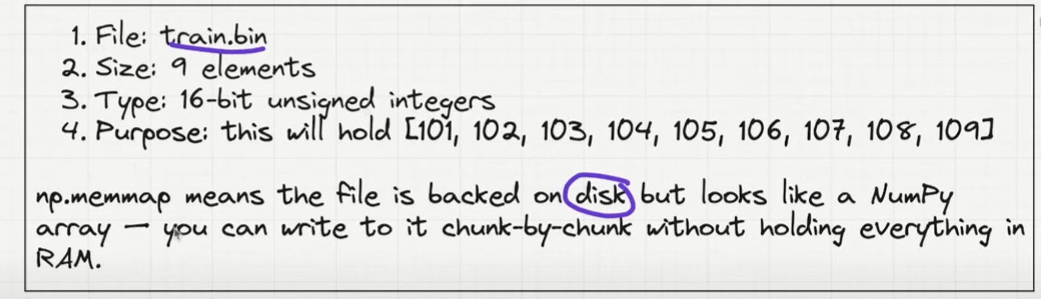

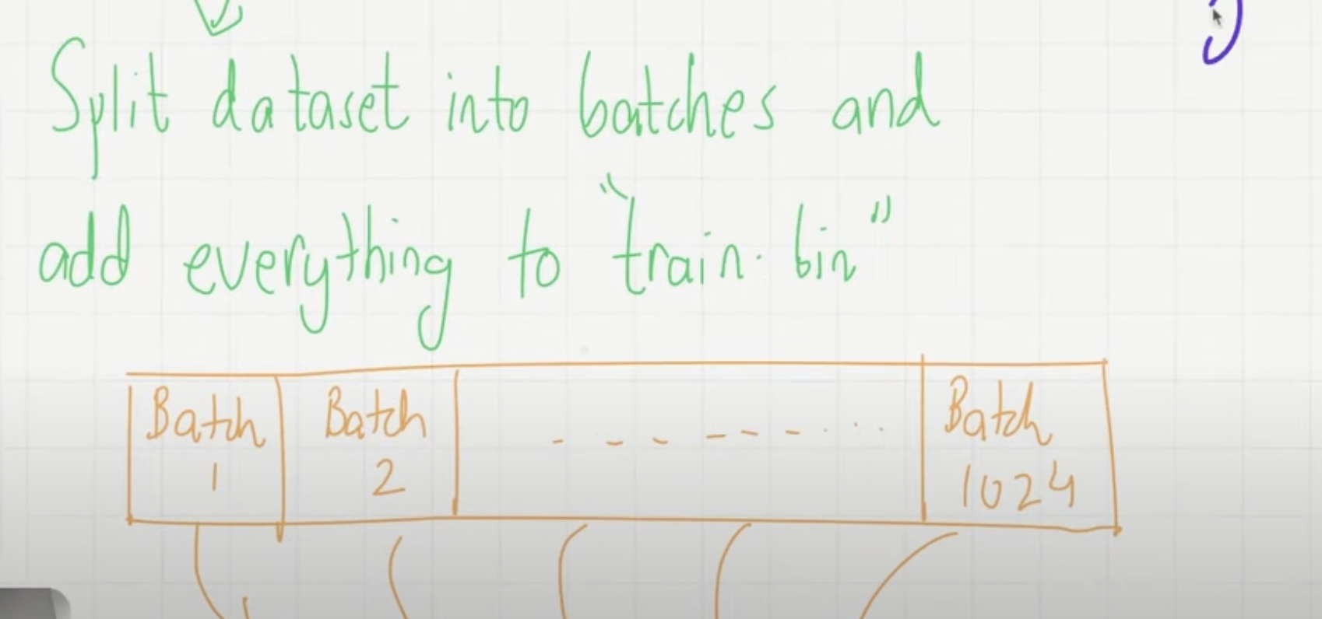

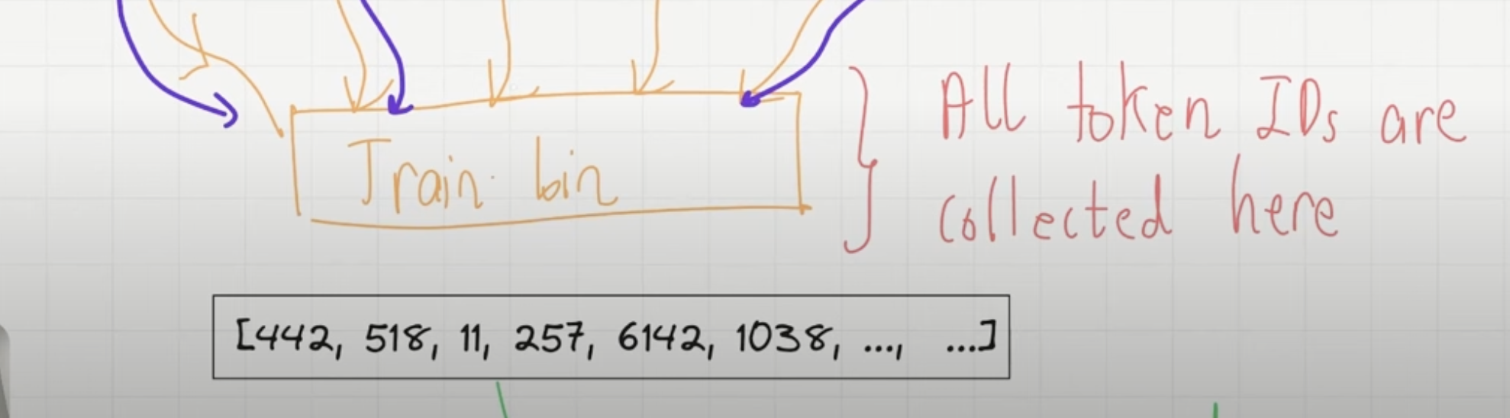

* Now all is stored in disk.
* Batches will help in doing it quickly.
* Tiktoken for GPT2

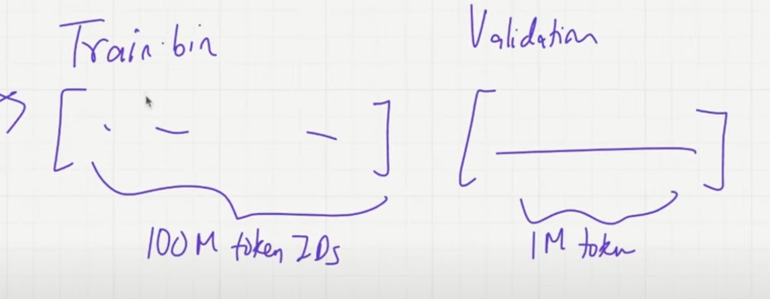

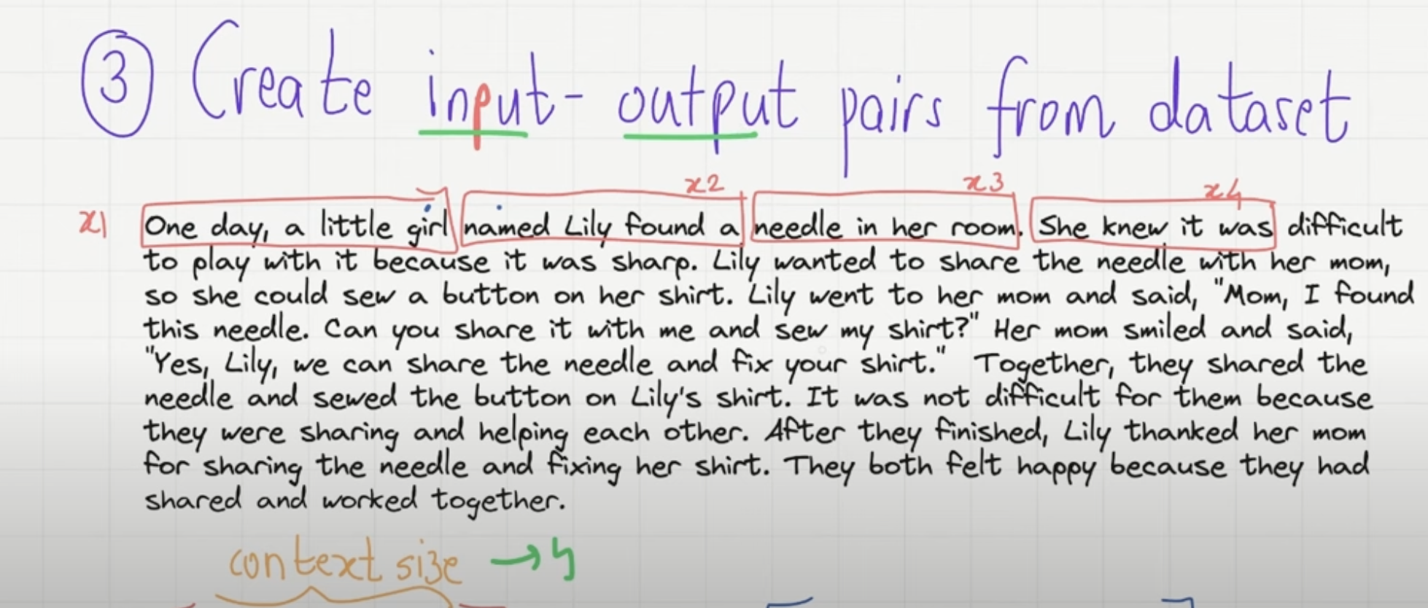

* Batch size = 4, Context size = 4. Divide the whole dataset into chunks of 4.
* For input, “One day a little”, output is “day a little girl”.

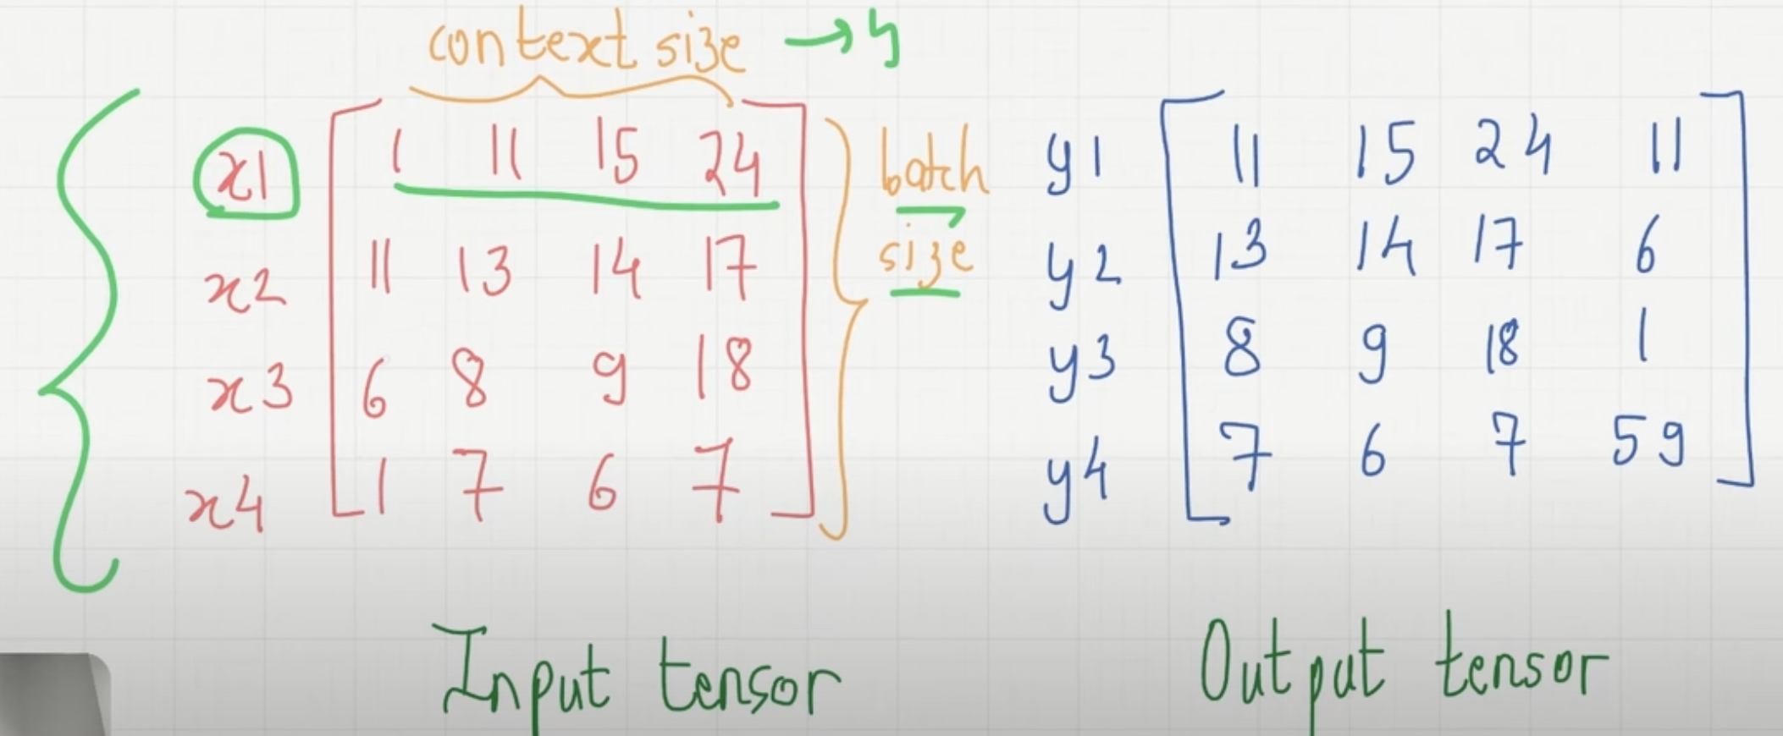

* For input and output pair, there are 4 prediction tasks, which are all next token prediction tasks.

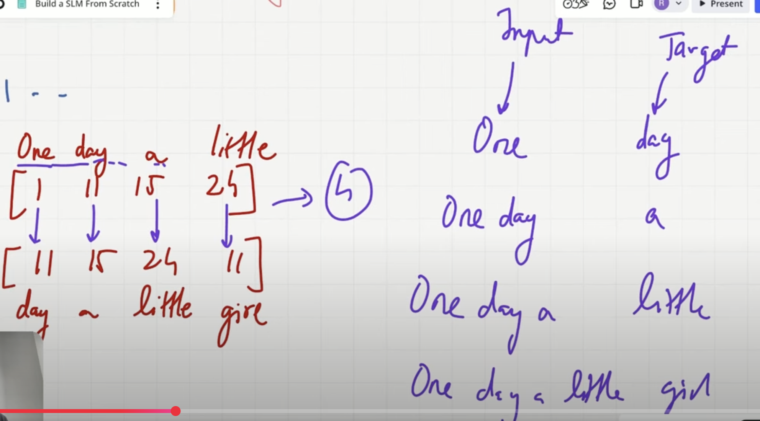

* In backpropagation, we have to ensure the input and ouput prediction is closer. We can get the loss from the output and the input and continue training.
* We sample randomly from batches.

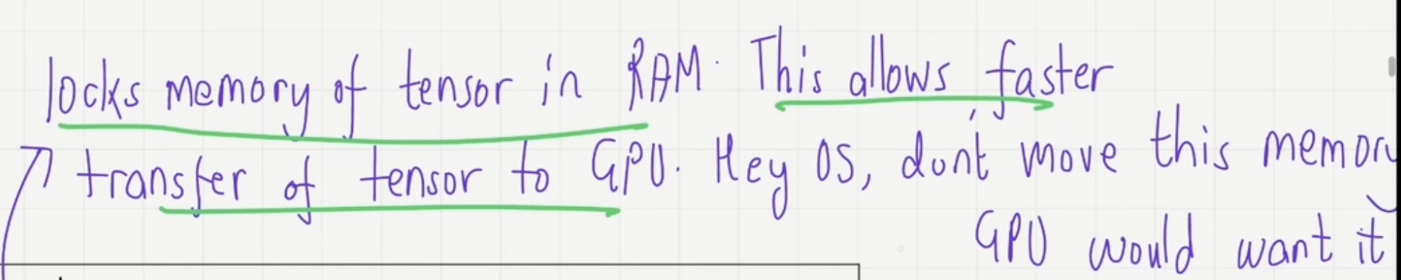

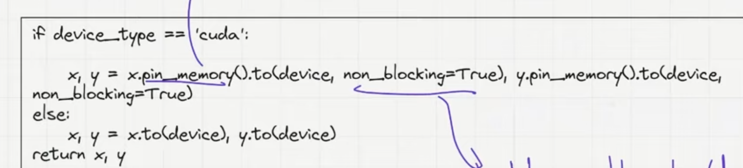

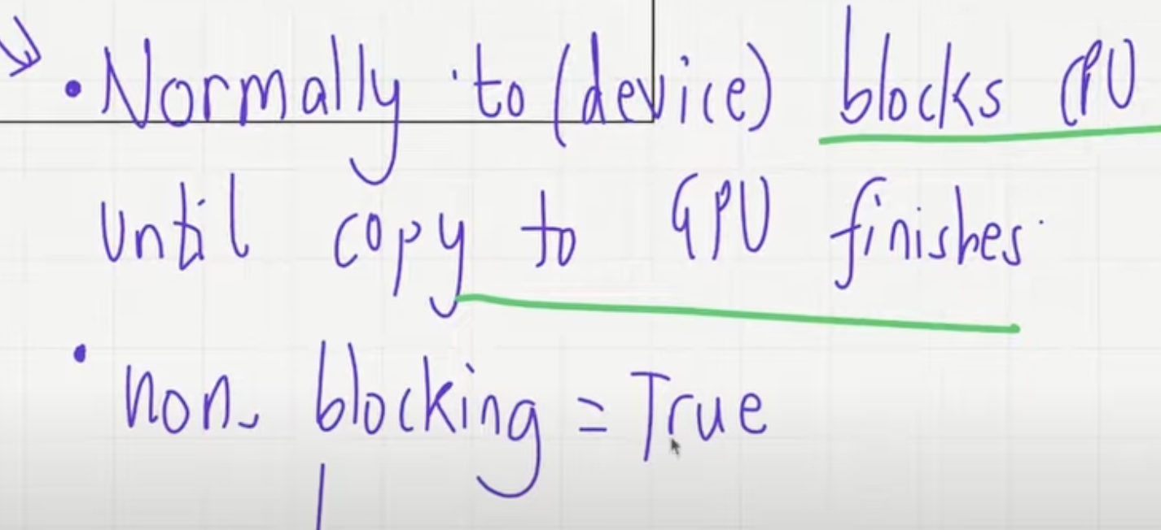

CPU can continue to do other tasks like next batch prep etc.

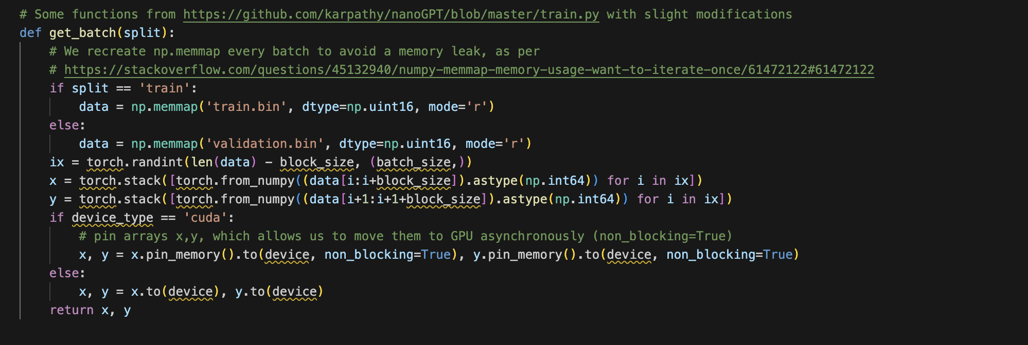

# Part 3 : Define the SLM architecture

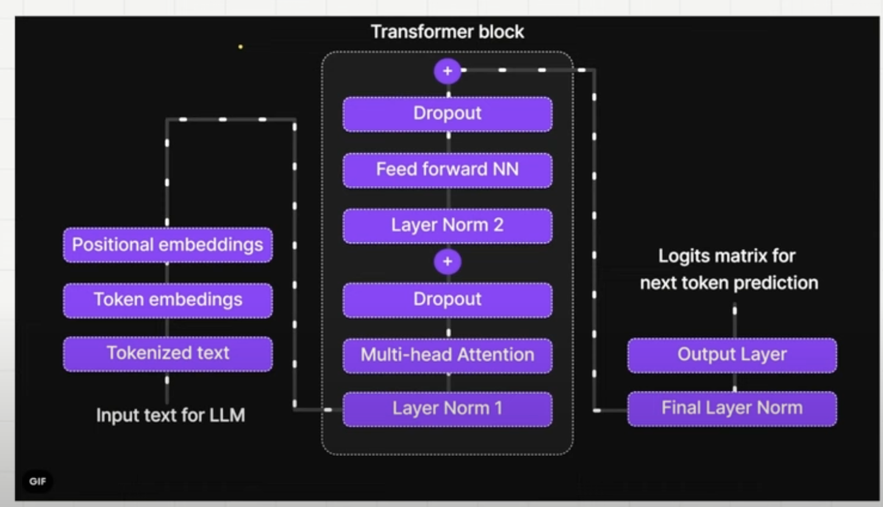

**Token Embeddings**

* Project token ids in higher embedding space.
* Look up table using the token Ids.
* The token embeddings are initialized randomly and learnt in the process of training.

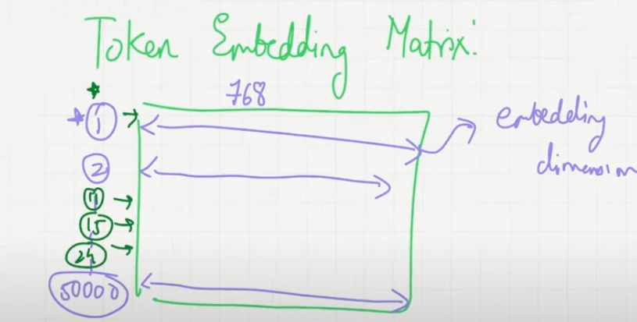

* **Importance of Layer Normalisation**
* **Problem - Internal Covariant Shift**
  + During backpropagation of training, the gradient of a layer depends on the output of the layer, so if the output fluctuates between large and small values, the gradient can stagnate or explode.
  + Training becomes hard if the distribution changes from one iteration to another.

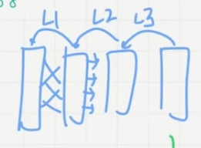

* **Solution** –
  + Layer normalisation prevents this problem by constraning the value within a certain range and makes the distribution similar.
  + Used to improve the training performance.

**Full Flow of one transformer block**

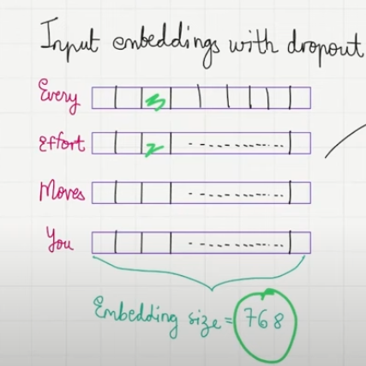 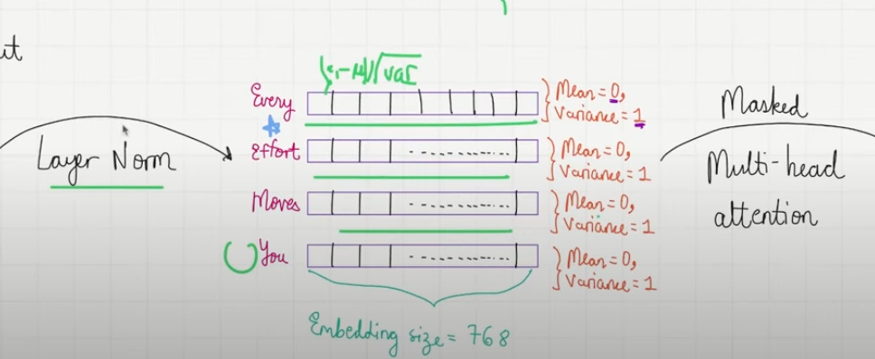 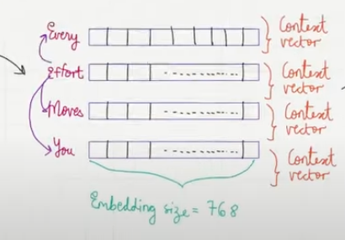

Dropout

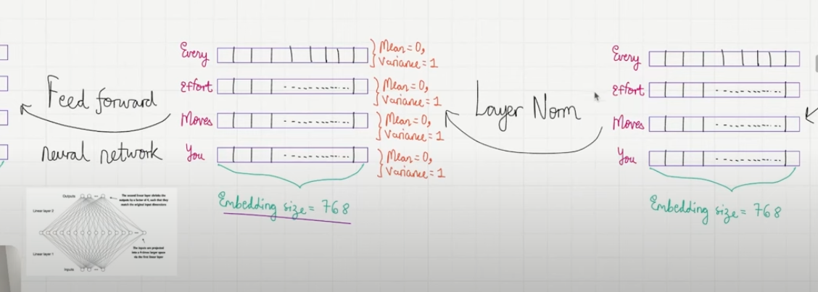 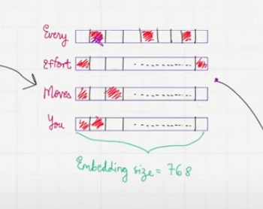

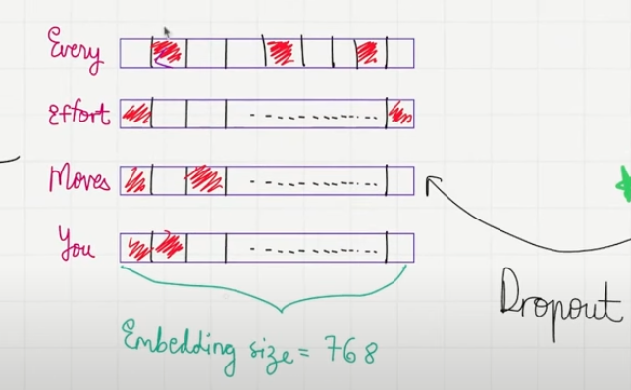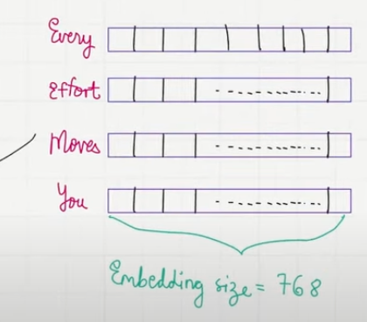

Shortcut connections

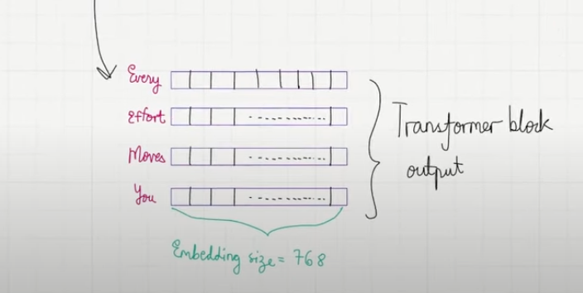 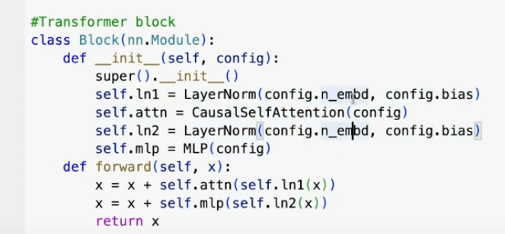

* Like this in GPT, there are multiple transformer blocks.

**Multi Head Attention**

* Till now no information about how one token is related to other tokens.
* The attention mechanism augments the input embedding vector such that it can have information about the neighbors. This is in the **form of Context vectors.**
* Here default was It. By default, it was a vector of 768 dimension but based on the context it was converted in a context vector.

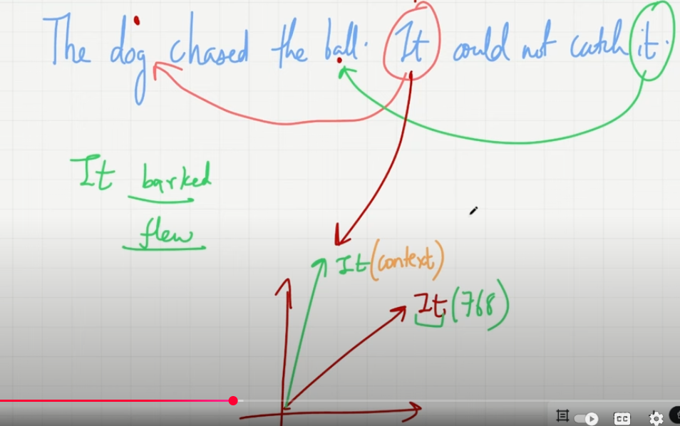

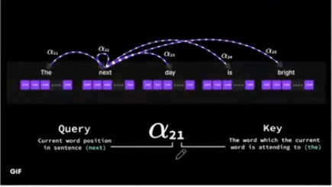 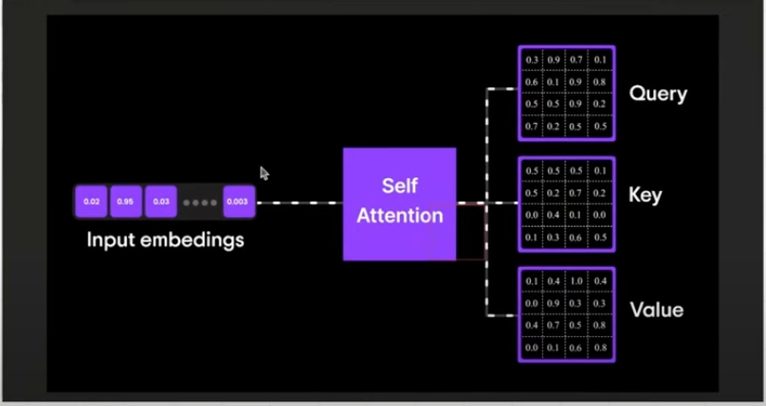

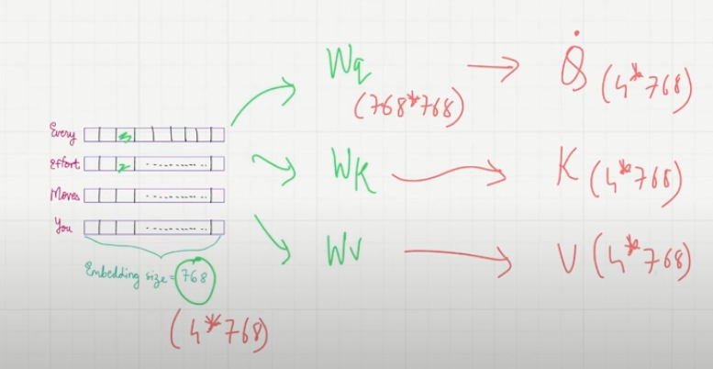 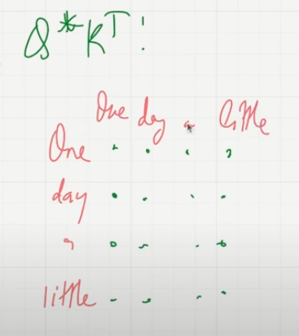

* All the parameters K, Q, V are learnt during training
* The results for 4-word sentence will be a 4*4 **attention score metrics** by Q*transpose (K)
* The attention weight metrics will be converted **into attention weight** metrics by dividing with squareroot (d) + softmax
* **Attention weights * V = Context vector (4 * 768)**
* There is a concept of causality (there cannot be attention score between (day,a) because a after day. For a token we can only focus on tokens which comes before it not which comes after it. So we can make them to 0. (In code, make a masked_fill to -infinite so that they can be 0 while we take softmax)

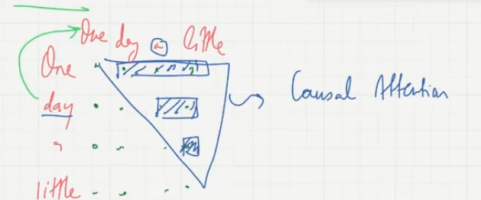

* A dropout is added after the causal attention block as a part of the acrchitecture.

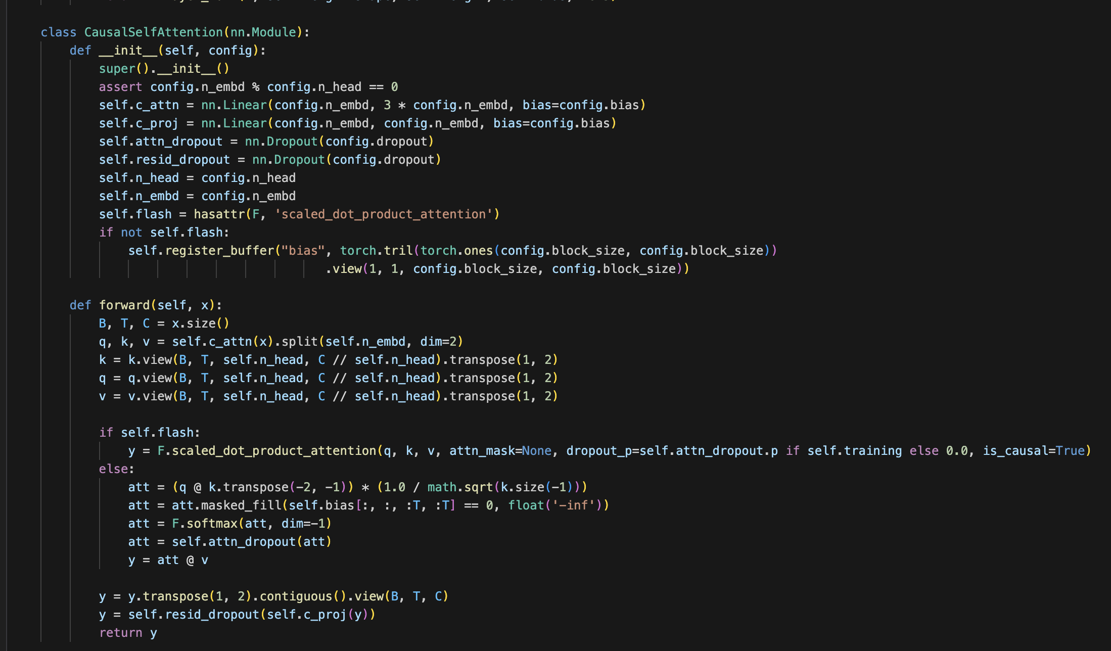

**Trainings needed for those, Weight Initializations**

* Token Embedding
* Positional Embedding
* Multi-head attention

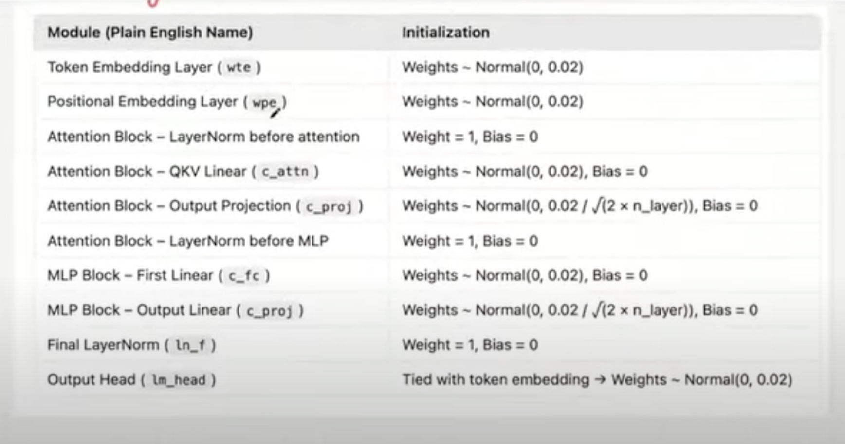

**Shortcut Connection**

* Flow gradients easily, alternate path to flow.
* Addressing Vanishing gradient problem
* Similar to resnet architecture
* 2 shortcut connections in this architecture.

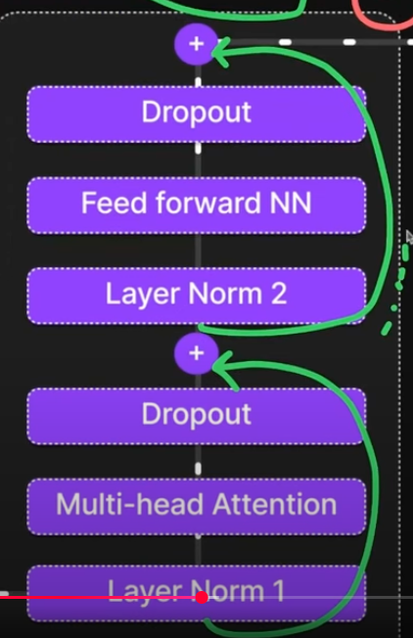

**Feed Forward NN**

* Expansion, Compression NN
* Concept - Project all into higher dimensional space to capture more non-linearities.
* Helps the language model to explore a richer space.
* Without NN, language model cannot learn the patterns.
* Actiavtion (GeLU) is used

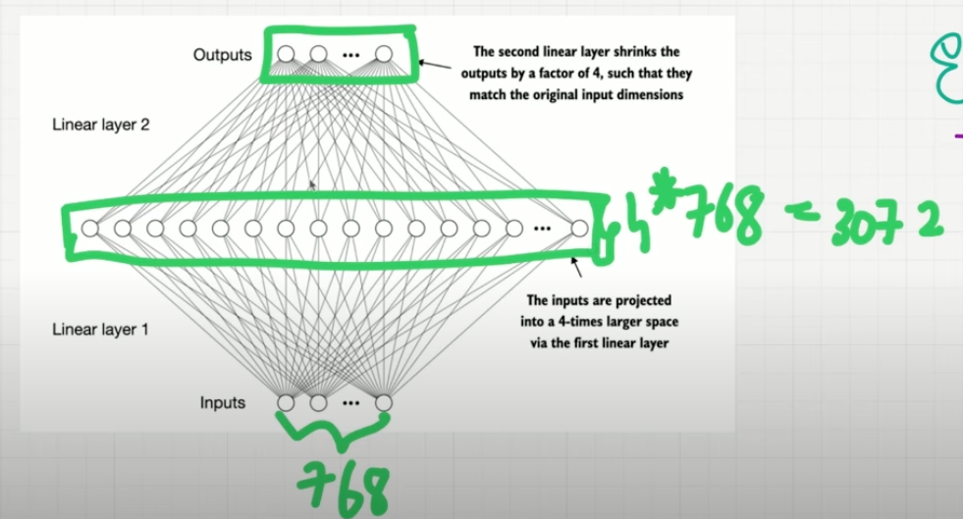 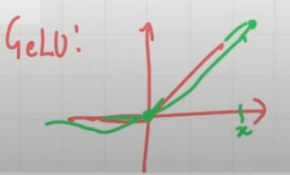

* In GPT there are multiple transformer blocks.

**Output Layer**

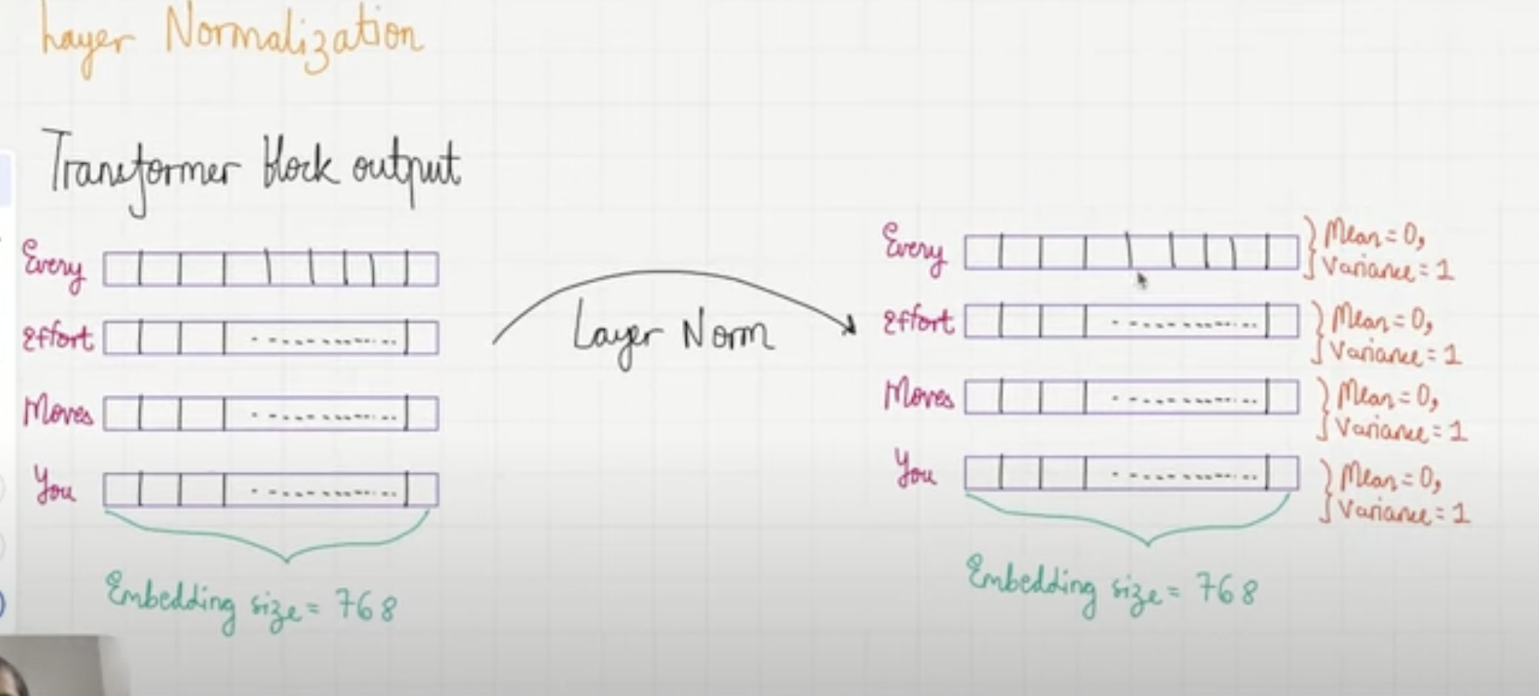

* Then the data goes to Output Head
* So till now it was 4 * 768 but now it will be 768 * vocabulary size. This is done by passing through the Neural network

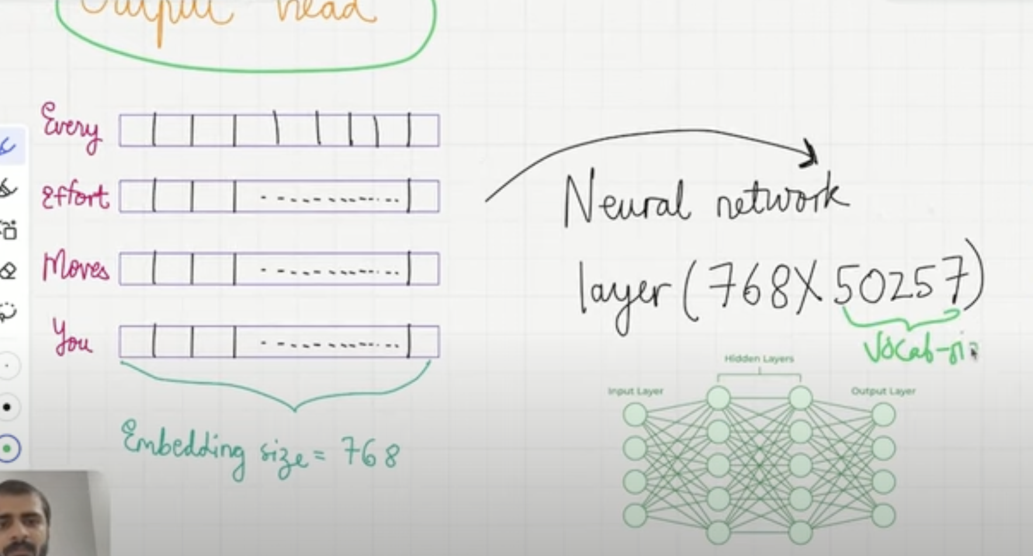

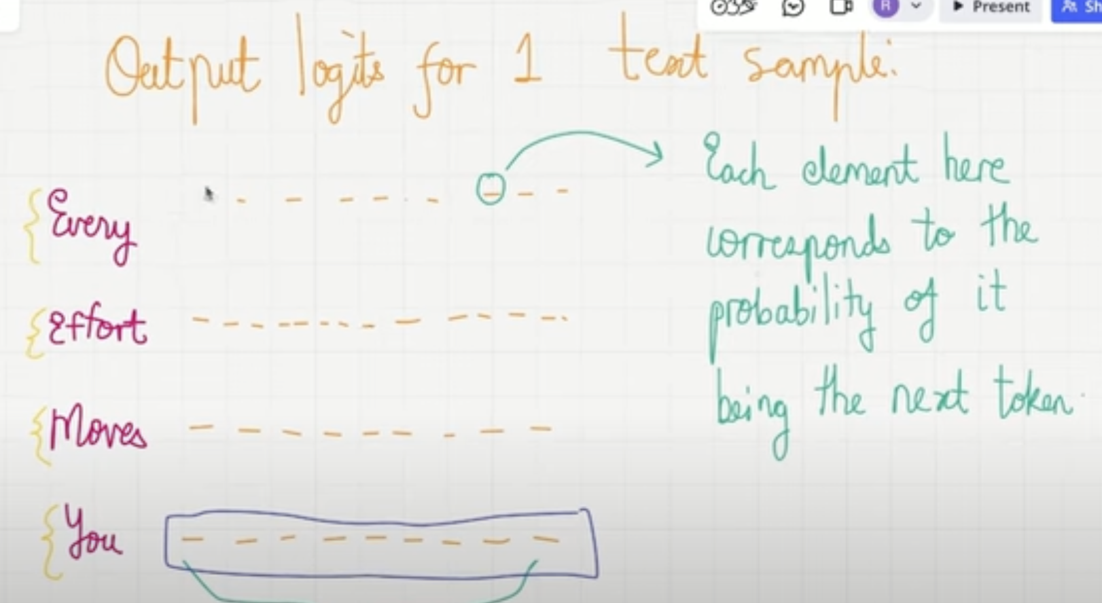

* **This logix matrix will be used to make the probability from the tokens.**
* **Then based on the prediction outputs and the targets, training will be done.**

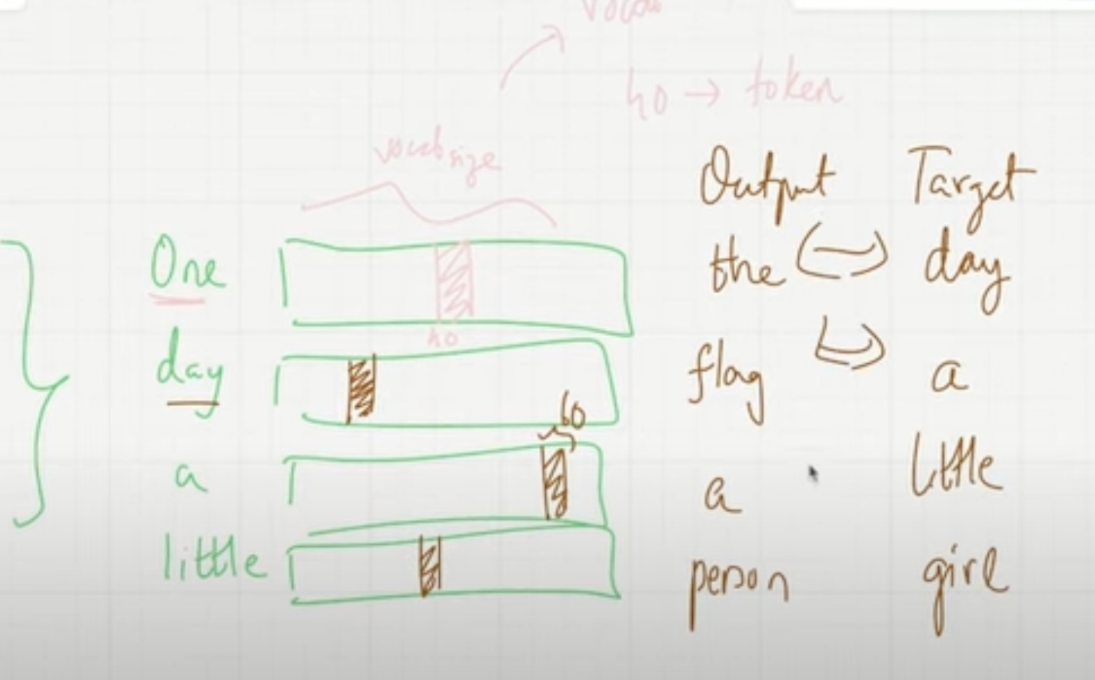

* For every batch my **cross-entropy loss = L1 + L2 + L3 + L4 for all 4 words**. Then I do the back propagations.

# SLM Loss function

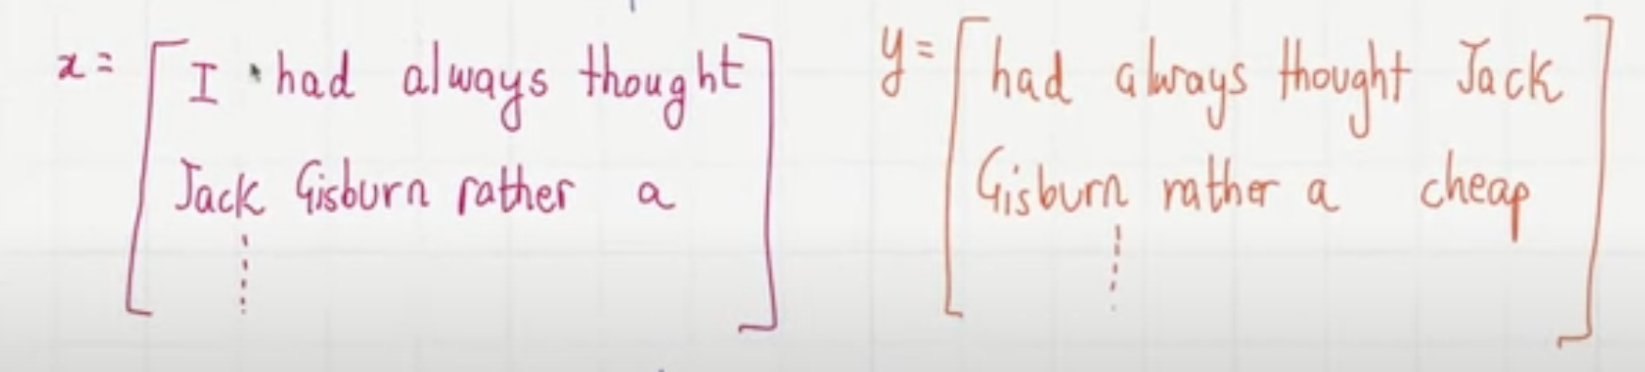

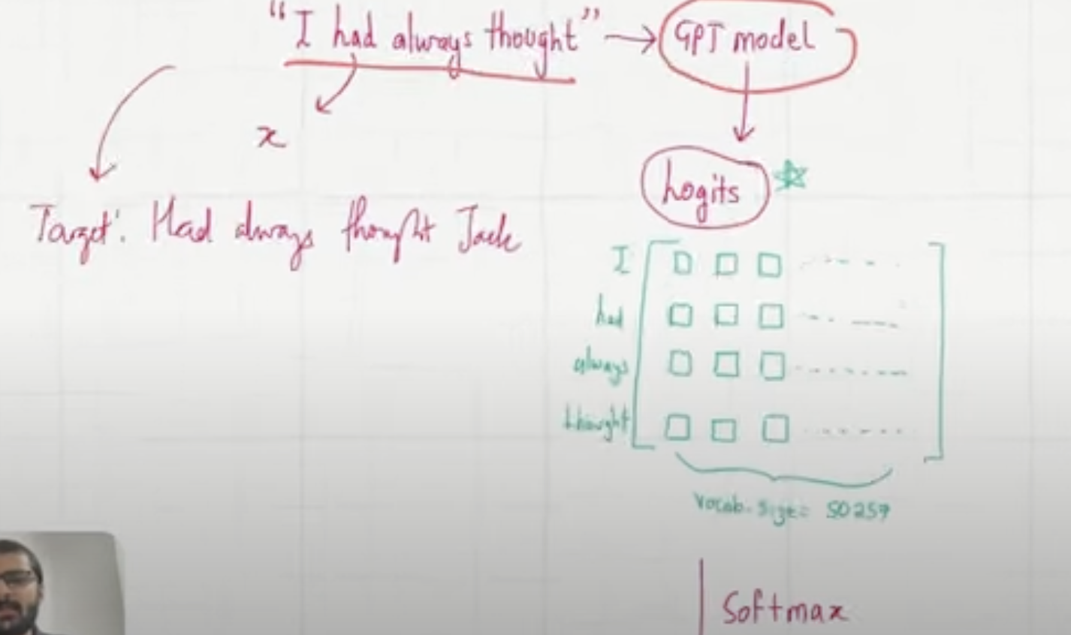

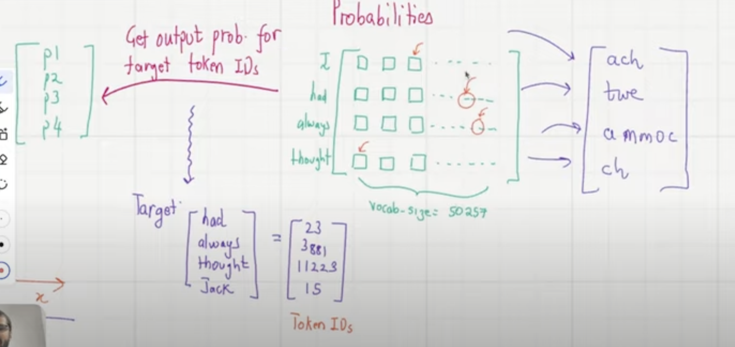

* Here lets consider the predicted token index as 35 and the target is 23. So the loss function is constructed only based on the token index which is 23. If index of 23 has probability of 0.01, I want to make it to close to 1. So I will make loss function based on index of 23.

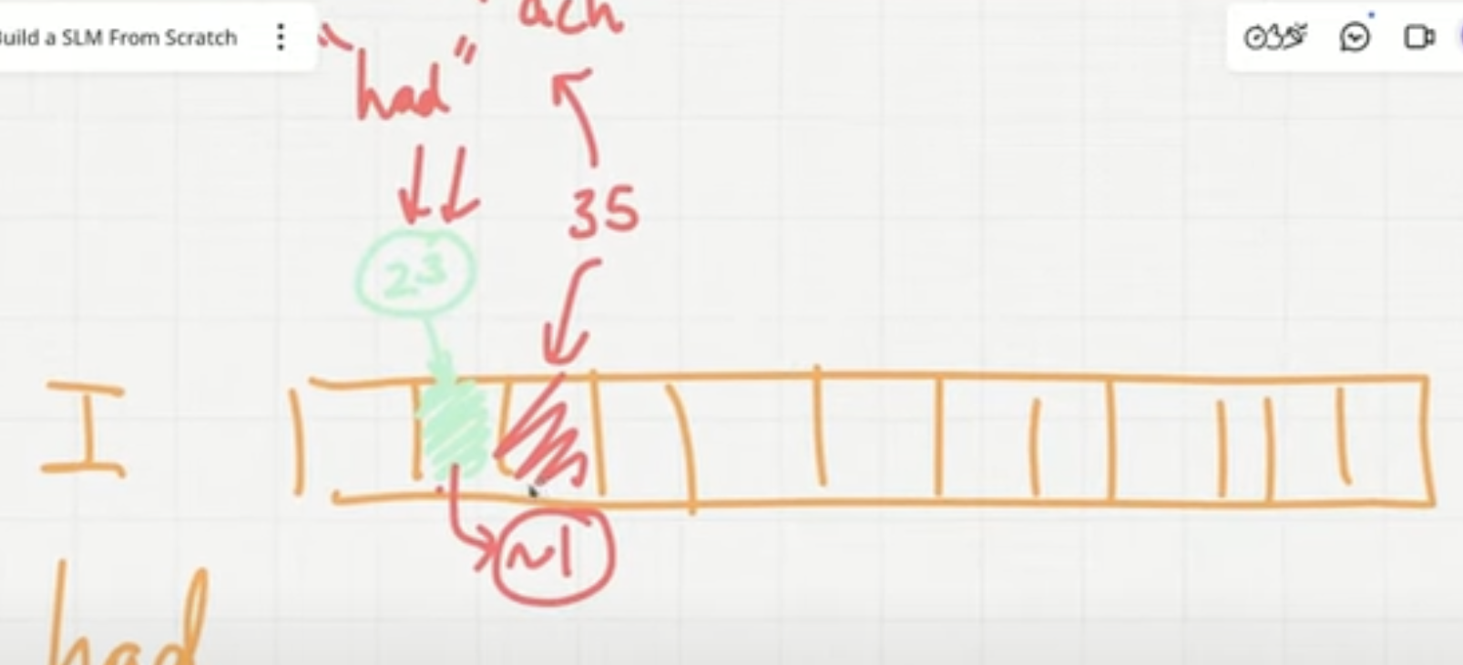

* We are trying to maximize all the probabilities so we take **cross-entropy loss** (**negative log likelihood**). We have to make p1,p2,p3,p4 close to 1.
  + If you p1*p2*p3*p4 derivative will be difficult in backpropagation. So log helps. -ve is to reduce the loss.

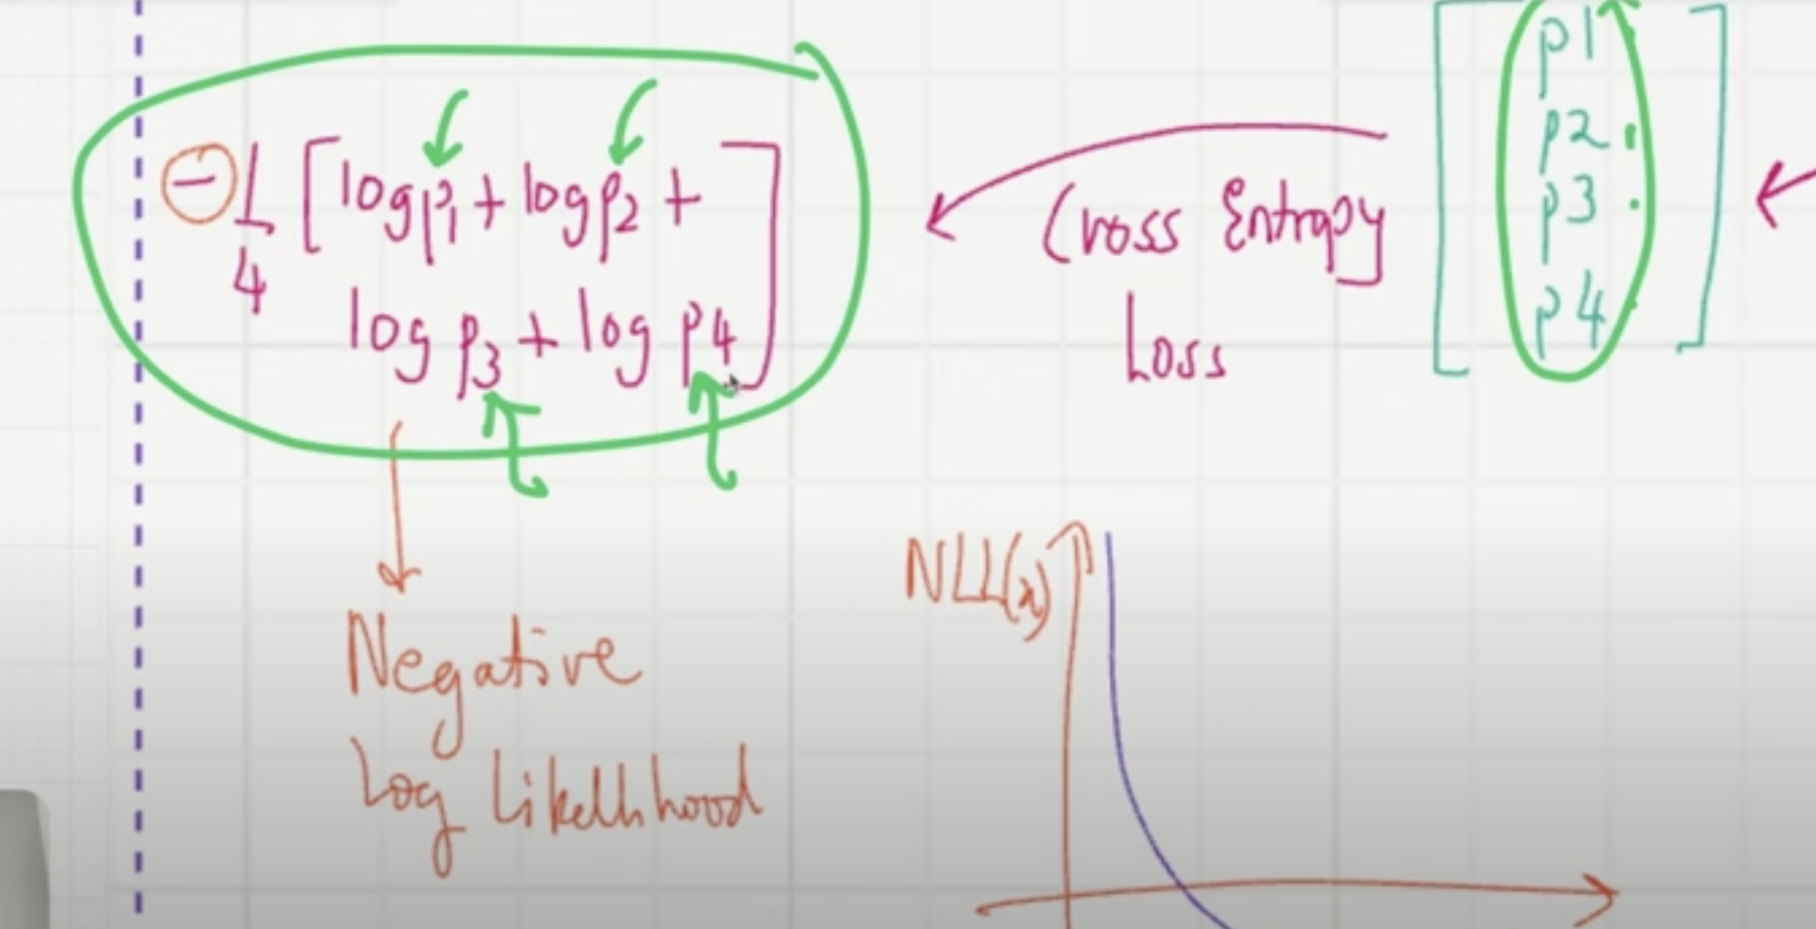

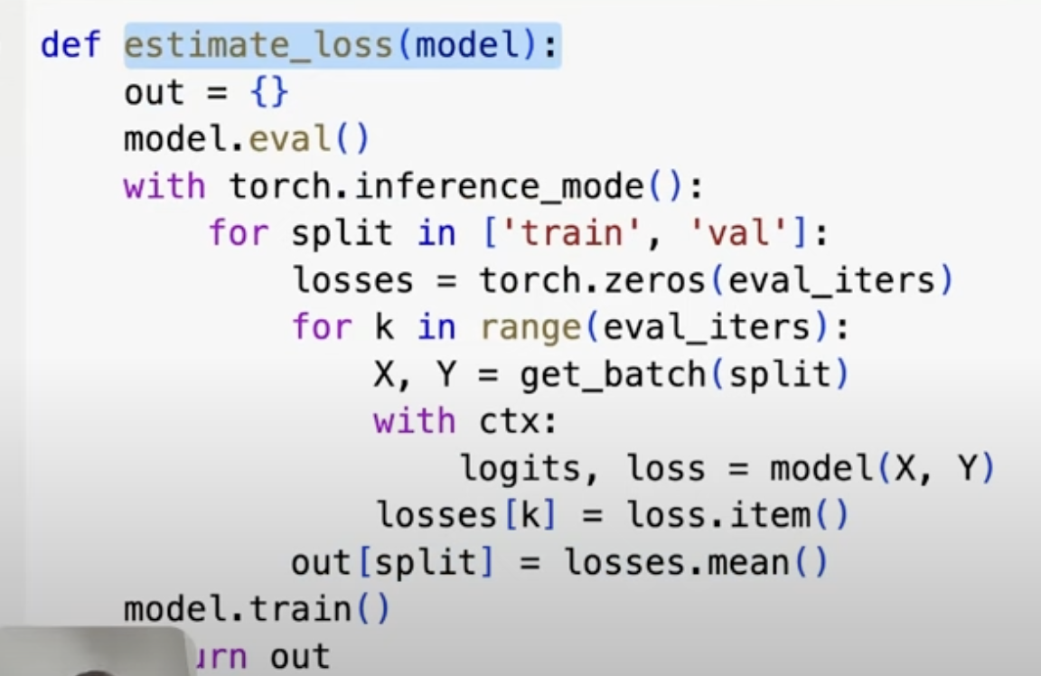

# Training Loop

* Till now we have done this below

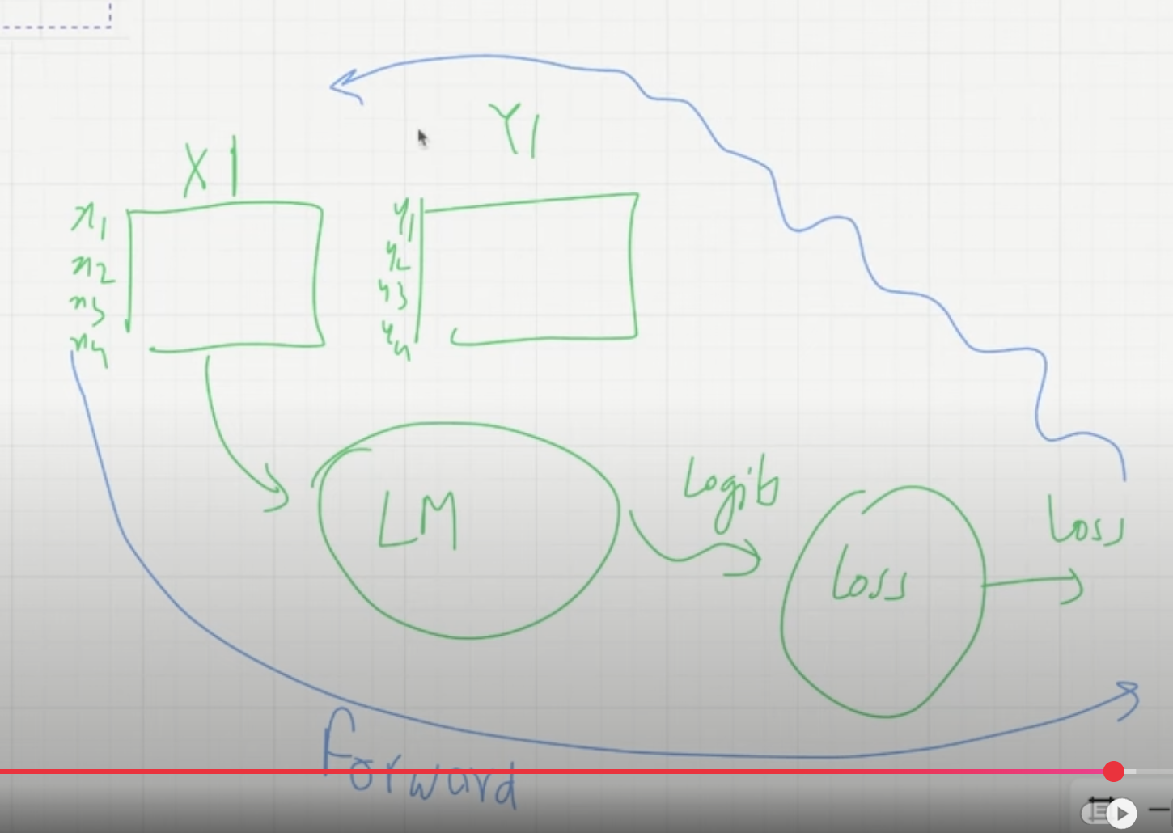

* Now lets understand the back propagation. We need to make our code run faster – production grade.

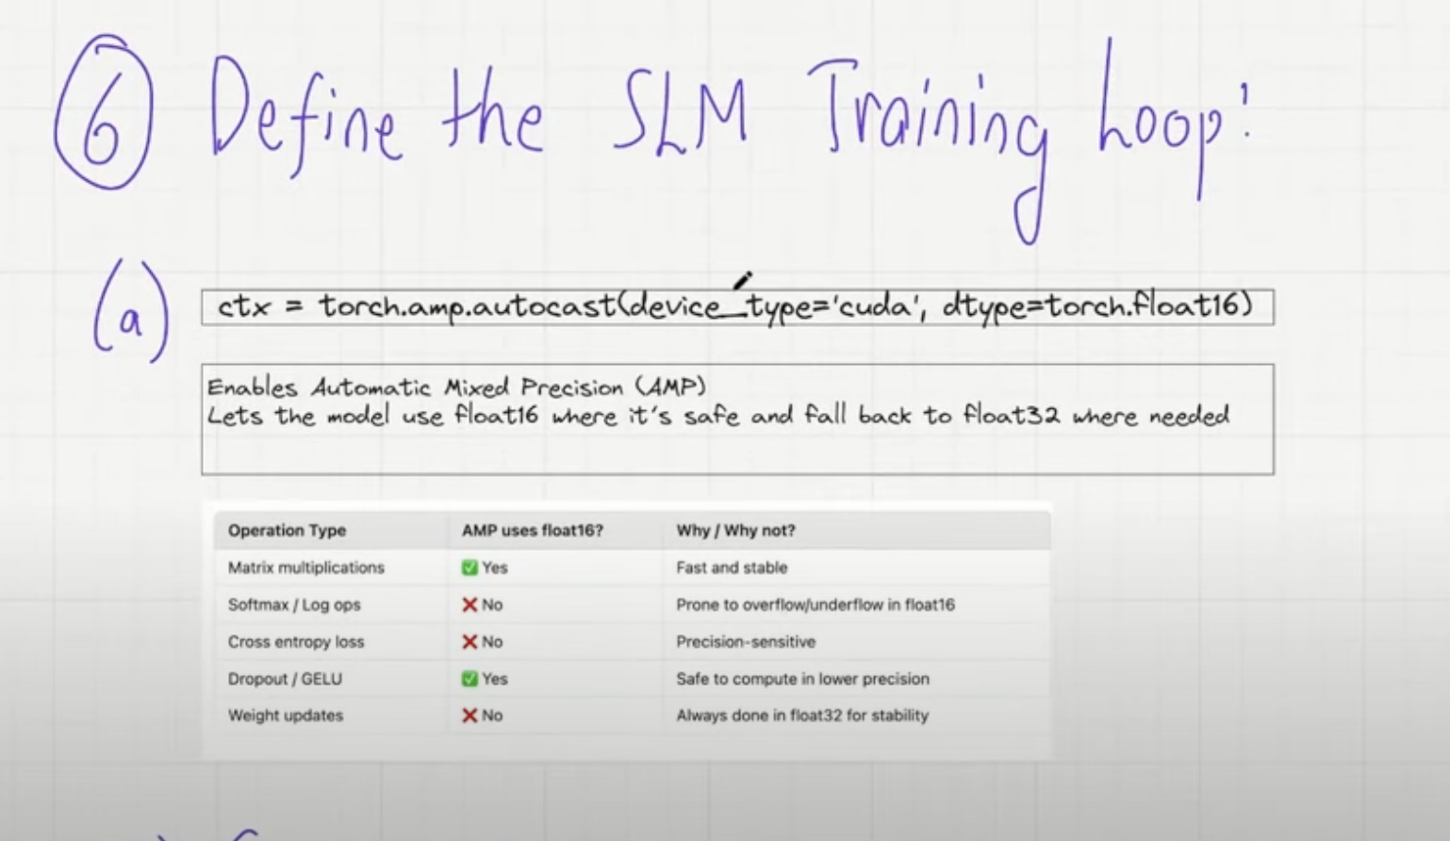

* These are some production grade tips. Autocast helps in maintaining the precesions such that computions run faster. It goes with float32 where there is precision required but not where it is not required (like Dropout, matrix *).

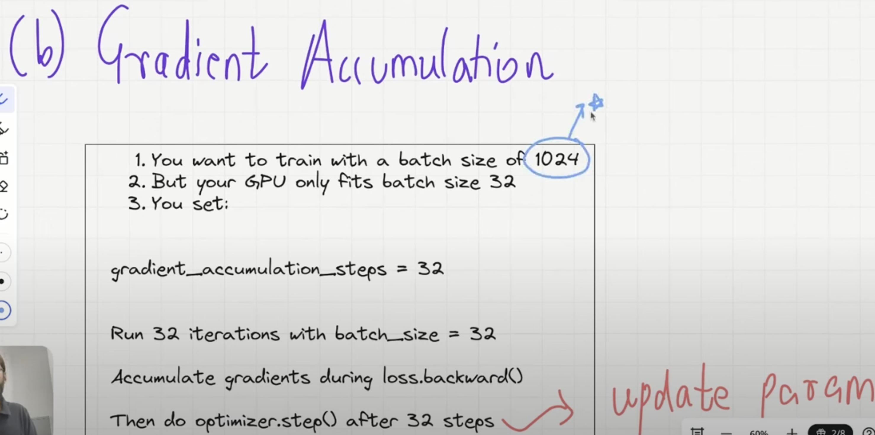

* If the batch size is huge like 1024 and your GPU can fit only 32 **use Gradient Accumulation**
* Here, batch size = 32, you run this loop 32 times, then calculate the gradient 32 times. After that take the mean and then **update the parameters** after that. (don’t update parameters after every gradient), also not after 1024 steps.

**( C) Adam Optimizer with Weight Decay**

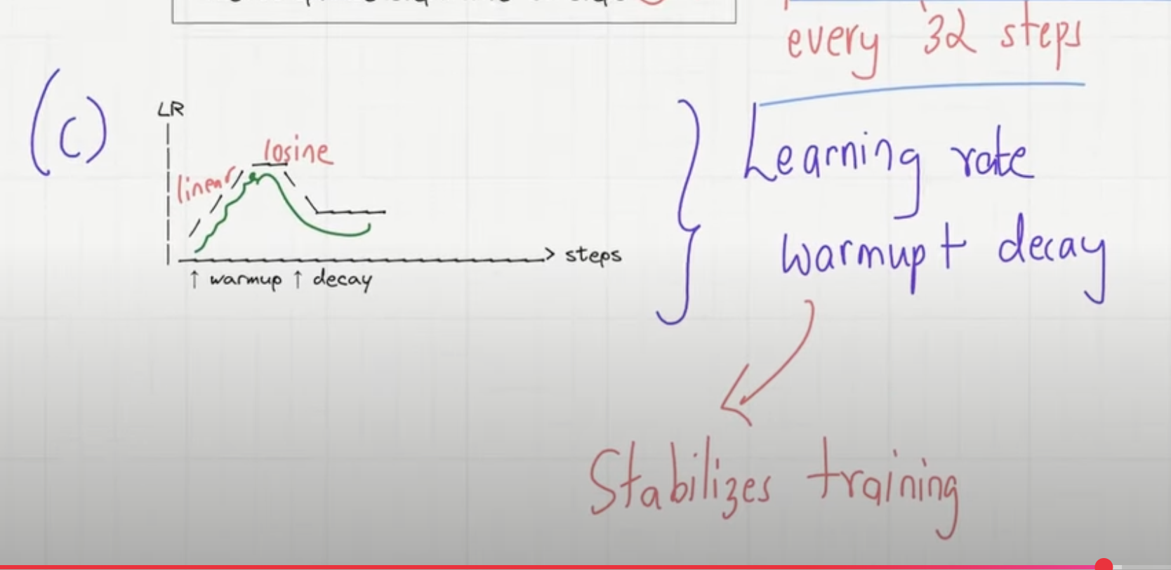

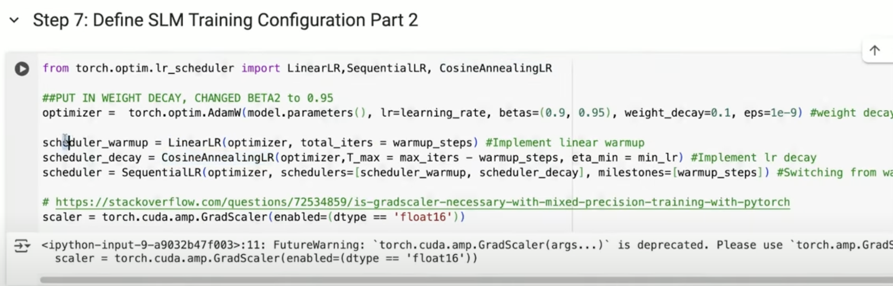

# Pretraining the SLM

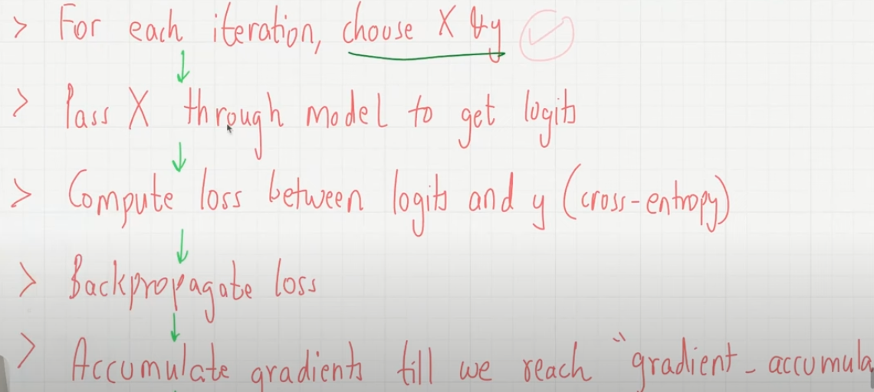

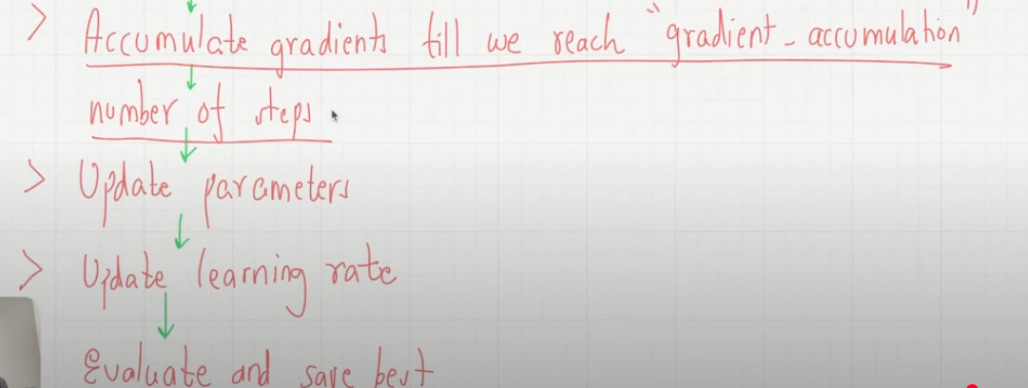

# Inference’

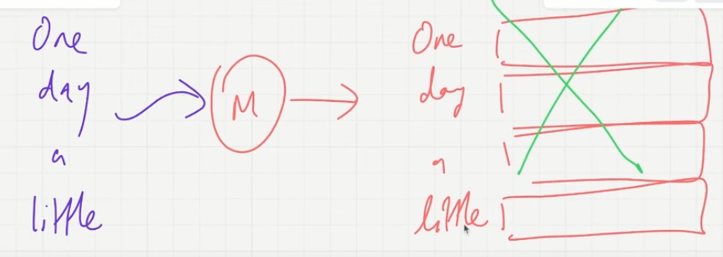

We don’t care of the first 3, only for the last token